**For part3, I extracted the strings from the global variables and converted them into char* variables:**

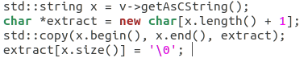

**I then passed these strings through the xor cypher to obfuscate the strings:**



**The result was this:**  
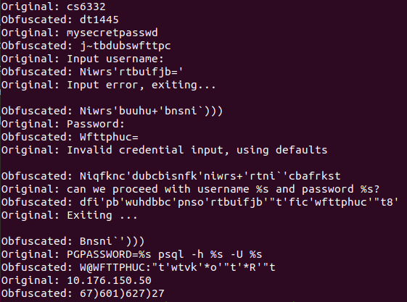

**I then changed the initializers of the string with the obfuscated string:**



**The result of dumping the new global initializer was this:**

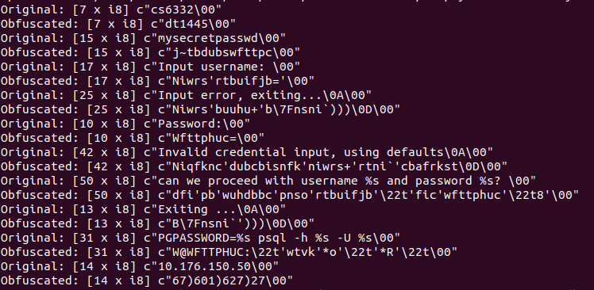

**I then tried to find all of the instructions that referenced the global strings using this:**

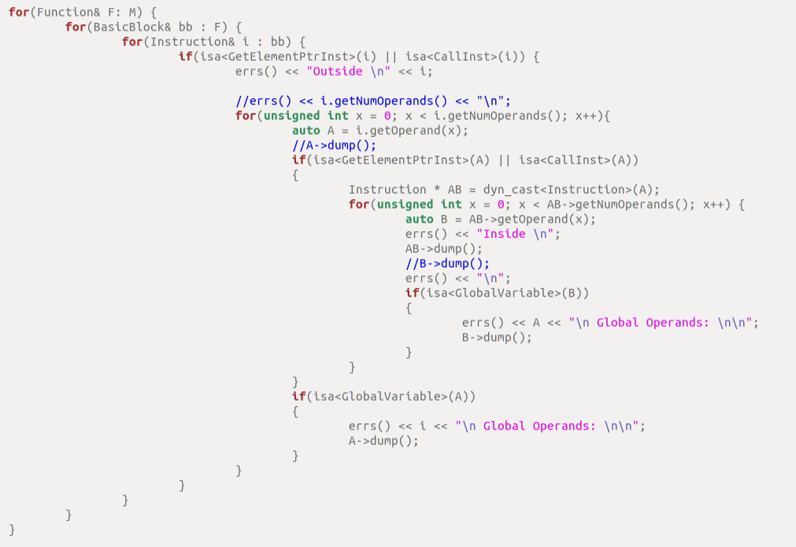

**However, I could not figure out the right syntax to iterate through the operands in the instructions because there was not enough time.**

**If I could find the right instructions, I would prepend the call to xorcypher using this**

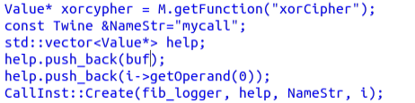

**Unfortunately, I was unable to find the complete solution, but I believe I made it about 80% there, and with more time I would have been able to.**